Pulaski Heights Elementary

Fifth Grade Supply List 2023-2024

1 Pair of Earbuds (wired)\* 1 wired mouse\*

1 Pair of Scissors 1 Package of Post It Notes

1 Box of Colored Pencils 1 pack of expo markers

1 Box of markers 2 wide rule notebooks

1 Box of crayons 2 2-Inch Binder

24 #2 Pencils 1 Pencil Pouch

1 Roll of Paper Towels 1 Container of Clorox Wipes

2 Pocket Folders without Prongs 1 Package of Loose-Leaf Paper

2 Composition Notebooks with Lines 2 Package of Dividers for Binders

1 Bottle of Hand Sanitizer                            1-2 Boxes of Kleenex

PHE Communication Folder (Orange)-Sold At PHE for $3

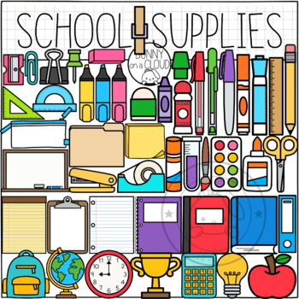\*We ask that you do not purchase Bluetooth items. This will help students to not cross signals and to keep up with their items.